**Методическая литература**

[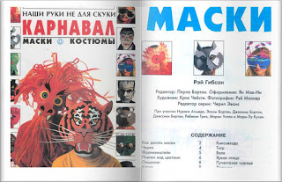](http://1.bp.blogspot.com/-xmbBupmgaL8/Vif10M2_ZCI/AAAAAAAAAwU/mEMTyF2i4U0/s1600/%D0%BA%D0%BD%D0%B8%D0%B3%D0%B0+%D0%9A%D0%B0%D1%80%D0%BD%D0%B0%D0%B2%D0%B0%D0%BB.jpg)

